**Selenium IDE Installation**

**Revision History**

|  |  |  |  |
| --- | --- | --- | --- |
| **Author** | **Date** | **Version** | **Description** |
| ViSolve | August 31, 2012 | 1.0 | **Initial revision** |

Contents

1 Introduction 4

2 Selenium IDE Installation 4

3 Conclusion 7

# Introduction

This document provides the steps to install Selenium IDE and run Selenium Scripts. Scripts which need a file to be uploaded have to be run in Selenium IDE 1.9.0.

# Selenium IDE Installation

1. Go to the following link

<http://seleniumhq.org/download/>

1. Click on [1.9.0](http://release.seleniumhq.org/selenium-ide/1.9.0/selenium-ide-1.9.0.xpi) under the section Selenium IDE to download that version
2. A pop up will appear showing Firefox prevented this site (seleniumhq.org) from asking you to install software on your computer.
3. Click on the Allow button in the popup. This action will download the Selenium IDE.
4. A message box appears. Click on the message box and then click on the Install Now button.
5. A pop up appears 5 add-ons will be installed after you restart Firefox. Click on the Restart Now button.
6. Download the Selenium scripts folder form github. **(Selenium script folder location: covidien_web/src/Test/selenium)**
7. Copy the testfiles (**covidien_web/src/Test/selenium/testfiles)**  folder to /home
8. After the Firefox is restarted Go to Tools🡪Selenium IDE
9. The following window should appear

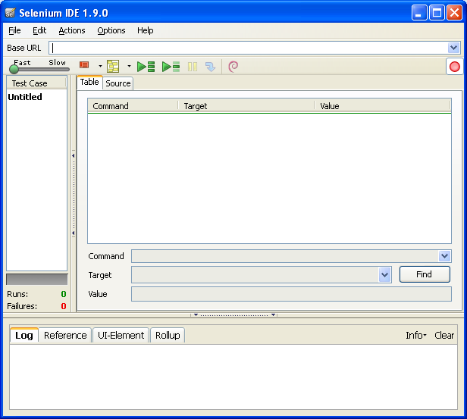

1. Click on File on the Top Menu.
2. Select Open Test Suite
3. Browse through the Selenium folder and select the file “Test suite.html” .
4. The test cases will get uploaded on the left pane and will be shown in the Selenium IDE as follows.

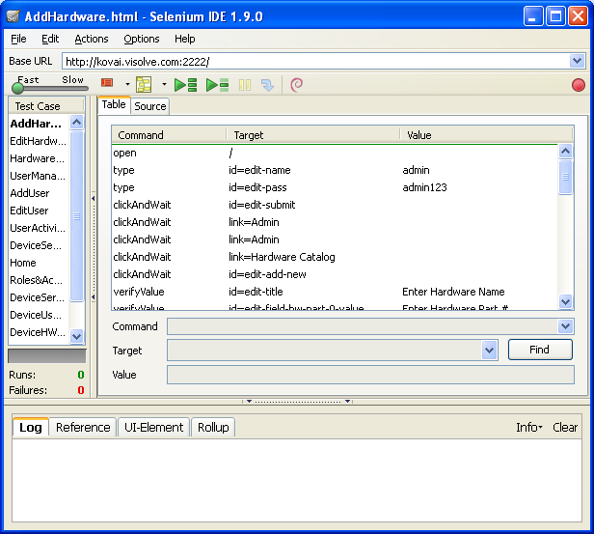

1. Double click on the First Test case in the left pane and Go to the Base URL part and type the URL where the application is deployed. Example <http://kovai.visolve.com:2222/>
2. Repeat the steps for all the test cases in the left pane.
3. Then click on  to run the test suite.
4. The test suite will run and when all the test cases are passed, the following window appears which indicates the file has run successfully without any issues.

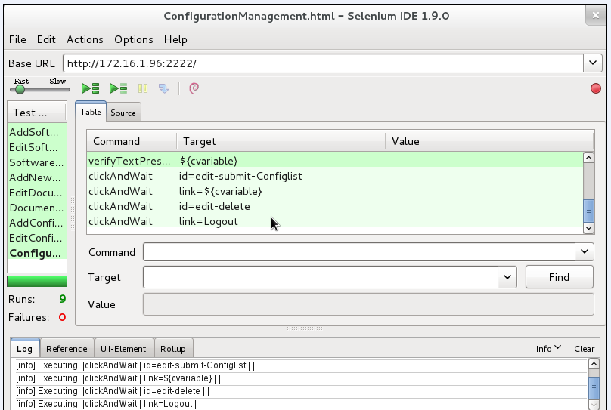

# Conclusion

The selenium tests will show as “0 Failures” to indicate that all the test cases have passed. If there are any failures, the corresponding test cases will be in RED.